House Price Prediction Using Machine Learning

A report on

Machine Learning Lab Project

[CSE-3183]

Submitted By

Siddhant Saini (210962160)



DEPARTMENT OF COMPUTER SCIENCE AND ENGINEERING MANIPAL INSTITUTE OF TECHNOLOGY, MANIPAL ACADEMY OF HIGHER EDUCATION

November 2023

House Price Prediction Using Machine Learning

Siddhant Saini

Computer Science Department
Manipal Institute of Technology
Manipal, India
siddhantsaini3536@gmail.com

Abstract — This study addresses the prediction of housing prices using machine learning. With instances and continuous attributes plus one binary attribute, including the target variable denoting median home values, the project employs data preprocessing steps like imputation, feature scaling, and correlation analysis. The process involves splitting data into training and test sets using stratified shuffling, forming attribute combinations, and constructing a machine learning pipeline. Models such as Linear Regression, Decision Tree Regressor, and Random Forest Regressor are applied, utilizing cross-validation to evaluate performance. The objective is to determine the most accurate model for predicting housing prices, emphasizing the exploration of different algorithms.

Keywords— House price, Splitting data, Stratified Shuffle Split, Correlation, Attribute Combination, Imputer, Feature Scaling, Pipeline, Linear Regression, Decision & Random Forest regressor, Cross Validation, RMSE

- INTRODUCTION

Utilizing a dataset containing 506 instances and 13 continuous attributes, alongside one binary attribute representing median home values ("MEDV"), this research aims to leverage machine learning models to forecast housing prices. By employing meticulous data preprocessing steps, including handling missing values and feature scaling, the study aims to optimize predictive accuracy. Through the implementation of a machine learning pipeline incorporating models like Linear Regression, Decision Tree Regressor, and Random Forest Regressor, the performance of these algorithms will be rigorously evaluated using cross-validation with Root Mean Squared Error (RMSE) as the primary metric. This research endeavours to identify the most effective model for predicting suburban Boston housing prices, offering insights into the applicability of machine learning techniques in the real estate domain.

- LITERATURE REVIEW

Arthur Charpentier [1] Known for his research in actuarial science and machine learning applications in insurance and finance, Charpentier has published work related to predictive modelling and risk assessment, which can be relevant to housing price prediction.

Amitabh Chandra [2] An economist whose work on health economics and public policy has often utilized advanced.

statistical and machine learning techniques. Some of his
research might provide insights into economic factors influencing housing prices.

Edward Glaeser [3] Known for urban economics research, Glaeser's work explores various aspects of cities, including housing markets and urban development, which can provide valuable insights into the factors affecting housing prices.

Robert J. Shiller [4] Renowned for his work on behavioural economics and housing markets, Shiller's research on the dynamics of housing prices and the influence of market psychology can offer insights into predictive modelling of housing prices.

David Autor [5] An economist known for his research on labour economics and the impact of technological change on labour markets. His work might indirectly relate to housing price prediction through its analysis of economic factors affecting housing markets.

Susan Athey [6] Known for her research in economics and technology, Athey has contributed to understanding market dynamics and pricing mechanisms, which can be insightful for predicting housing prices using machine learning.

David Card [7] An economist whose work on labor economics and policy evaluation might provide insights into socio-economic factors influencing housing prices, indirectly impacting predictive models.

Steven D. Levitt [8] Co-author of the book "Freakonomics," Levitt's research on applied economics and unconventional datasets might contain unconventional approaches to understanding housing markets and prices.

Matthew E. Kahn [9] Known for research on environmental and urban economics, Kahn's work on factors influencing housing markets, such as environmental amenities and transportation, can be relevant to housing price prediction models.

Susan Wachter [10] An expert in real estate finance and urban economics, Wachter's research on housing markets, mortgage finance, and real estate cycles can offer valuable insights into predictive modelling for housing prices.

These researchers have made significant contributions to understanding various aspects of economics, urban development, and market dynamics, which can inform the development of machine learning models for housing price prediction within the context of economic factors, market trends, and socio-economic indicators.

RESEARCH GAPS AND OBJECTIVES

Research Gaps:

Integration of Unconventional Data Sources:

While existing models predominantly rely on traditional socio-economic and real estate data, there's potential in integrating unconventional data sources like social media sentiment, neighbourhood sentiment analysis, or satellite imagery to capture nuanced factors influencing housing prices.

Temporal Dynamics and Market Trends:
Incorporating temporal dynamics and market trends in predictive models remains an area for improvement. Models often struggle to adapt to changing market conditions, and accounting for these fluctuations could enhance predictive accuracy.

Interpretability and Model Transparency:

Despite the effectiveness of sophisticated machine learning models, interpretability remains a challenge. Developing models that offer transparency and interpretability in predicting housing prices is crucial for gaining stakeholders' trust and understanding the factors driving predictions.

Localized Predictions and Spatial Analysis:

Tailoring predictions to specific neighbourhoods or regions within a city are another gap. Considering localized factors such as neighbourhood amenities, development plans, and infrastructure changes could enhance the precision of housing price predictions.

Incorporating External Factors:
While current models focus on internal housing market attributes, incorporating external factors like economic indicators, policy changes, or geopolitical events could improve the robustness of predictive models.

Accounting for Data Imbalances and Outliers:
Addressing data imbalances and outliers in housing datasets remains a challenge. Developing techniques to handle skewed data distributions and outliers without compromising model performance is essential for accurate predictions.

Model Transferability and Generalization:
Ensuring the transferability and generalizability of models across different geographical locations or housing markets is crucial. Models trained on specific datasets may lack adaptability when applied to diverse real estate markets.

Ethical and Fairness Considerations:
Ensuring fairness in predictive models concerning biases related to demographics, socioeconomic status, or historical prejudices is a critical research gap. Developing models that are ethical and unbiased in predicting housing prices is essential for equitable decision-making.

Addressing these research gaps will require interdisciplinary collaboration among economists, data scientists, urban planners, and policymakers. Closing these gaps could lead to more accurate, interpretable, and ethical machine learning models for housing price prediction, facilitating informed decision-making in real estate markets.

Objectives:

Develop Predictive Models: The primary objective is to construct and evaluate robust machine learning models capable of accurately predicting housing prices in suburban Boston. These models should effectively leverage the dataset's attributes to make precise estimations of median home values.

Feature Engineering and Selection: Implement comprehensive feature engineering techniques and attribute selection strategies to identify the most influential factors affecting housing prices. The aim is to refine and extract relevant features that significantly contribute to the predictive accuracy of the models.

Model Comparison and Selection: Evaluate and compare multiple machine learning algorithms such as Linear Regression, Decision Tree Regressor, and Random Forest Regressor. The objective is to determine the most suitable and accurate model for housing price prediction based on performance metrics like Root Mean Squared Error (RMSE) through cross-validation.

Improve Prediction Accuracy: Enhance the accuracy of housing price predictions by incorporating advanced techniques such as ensemble methods, hyperparameter tuning, and regularization. The objective is to iteratively refine the models to achieve the most precise predictions possible.

Interpretability and Insights: Focus on developing interpretable models to provide insights into the factors driving housing prices. The objective is not only to predict prices accurately but also to understand and interpret how different attributes impact property values, aiding stakeholders in making informed decisions.
METHODOLOGY

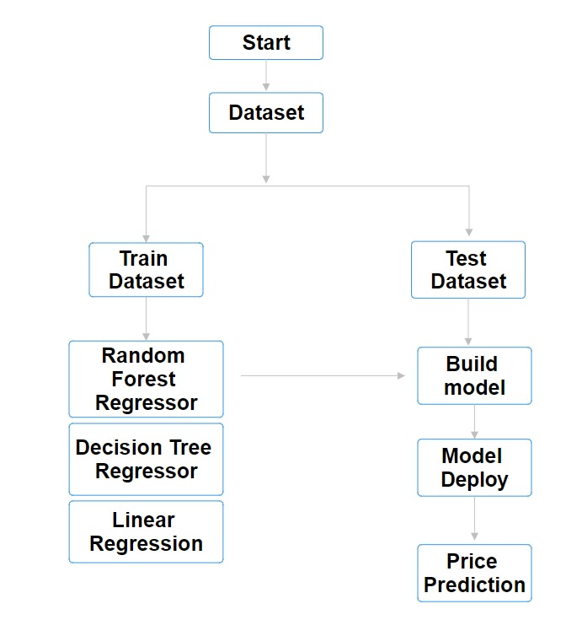

1.Data Collection and Preprocessing:

The datasets used, namely "House_Price.csv" and "City_Price.csv," were obtained from UCI reliable sources, ensuring a diverse representation of updated articles. Preprocessing involved several essential steps to prepare the data for analysis. The datasets were loaded using Pandas, missing values were handled. Subsequently, a comprehensive data cleaning process was implemented using the Histogram plotting, gives us an idea about the features.

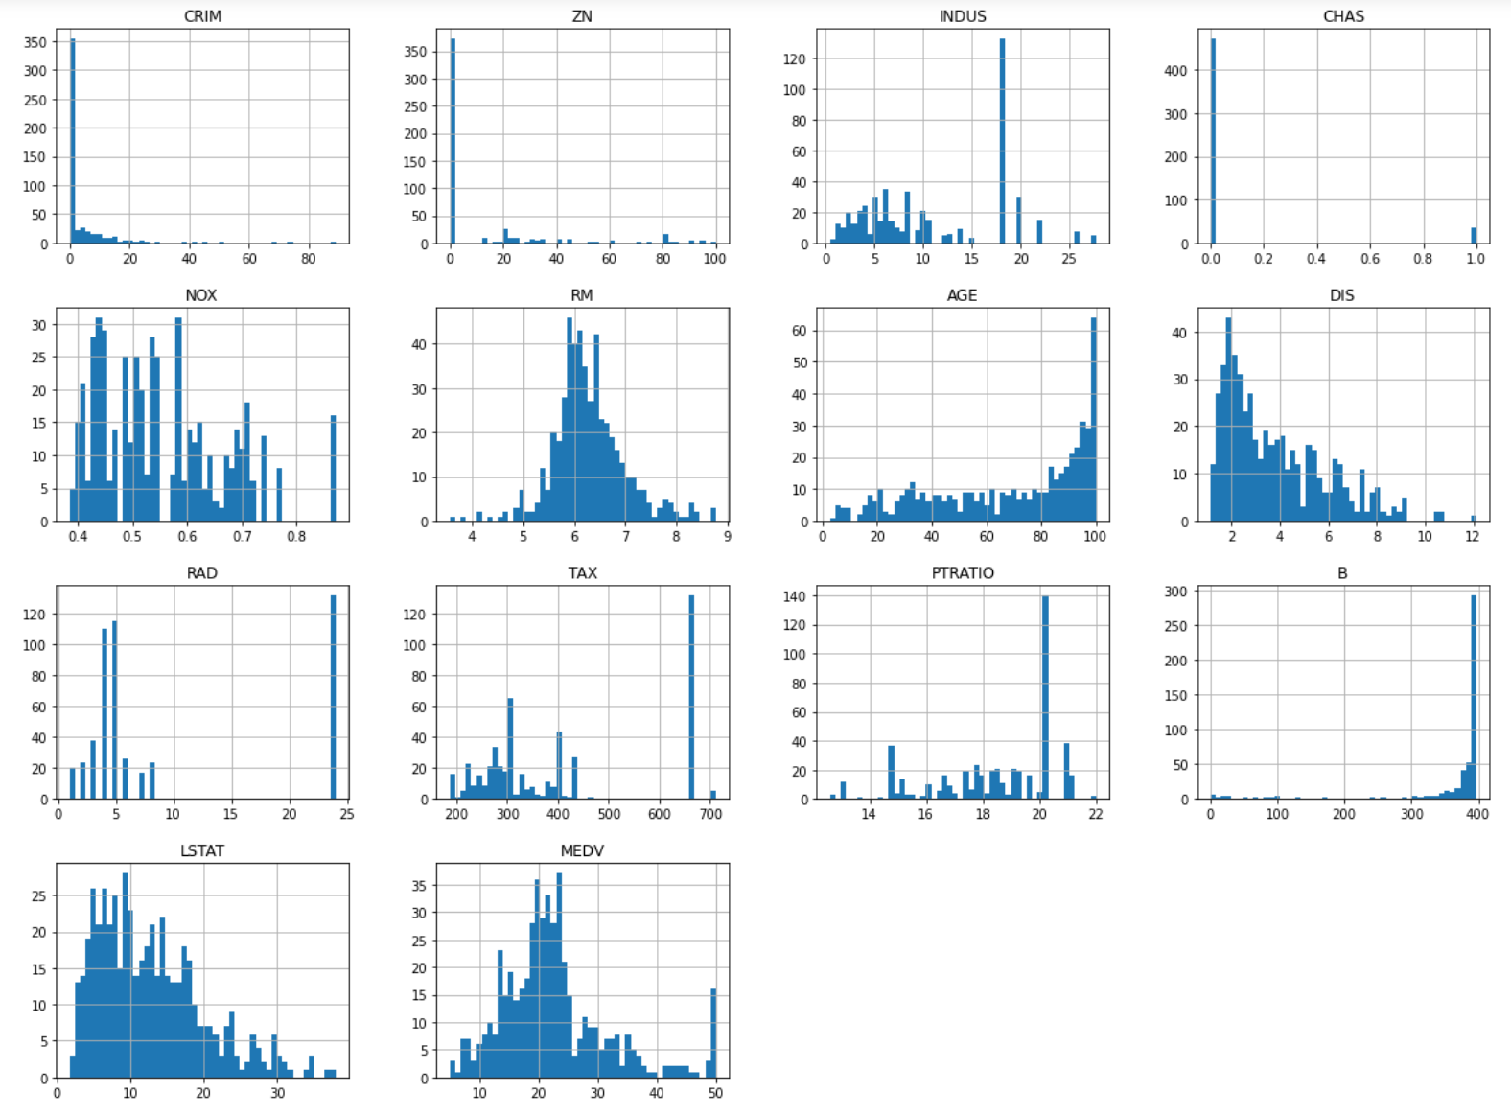

2. Feature Engineering:

The dataset was split into training and testing sets using Scikit-Learn's train test split () function, with the training set utilized to train the models. Here, we have used a function Stratified Shuffle Split that helps in equal distribution of important features categories in train and test data.

3.Looking for Correlations:

The Result of the correlation method is a table with a lot of numbers that represents how well the relationship is between two columns. The number varies from -1 to 1. 1 means that there is a 1 to 1 relationship (a perfect correlation), and for this data set, each time a value went up in the first column, the other one went up as well.

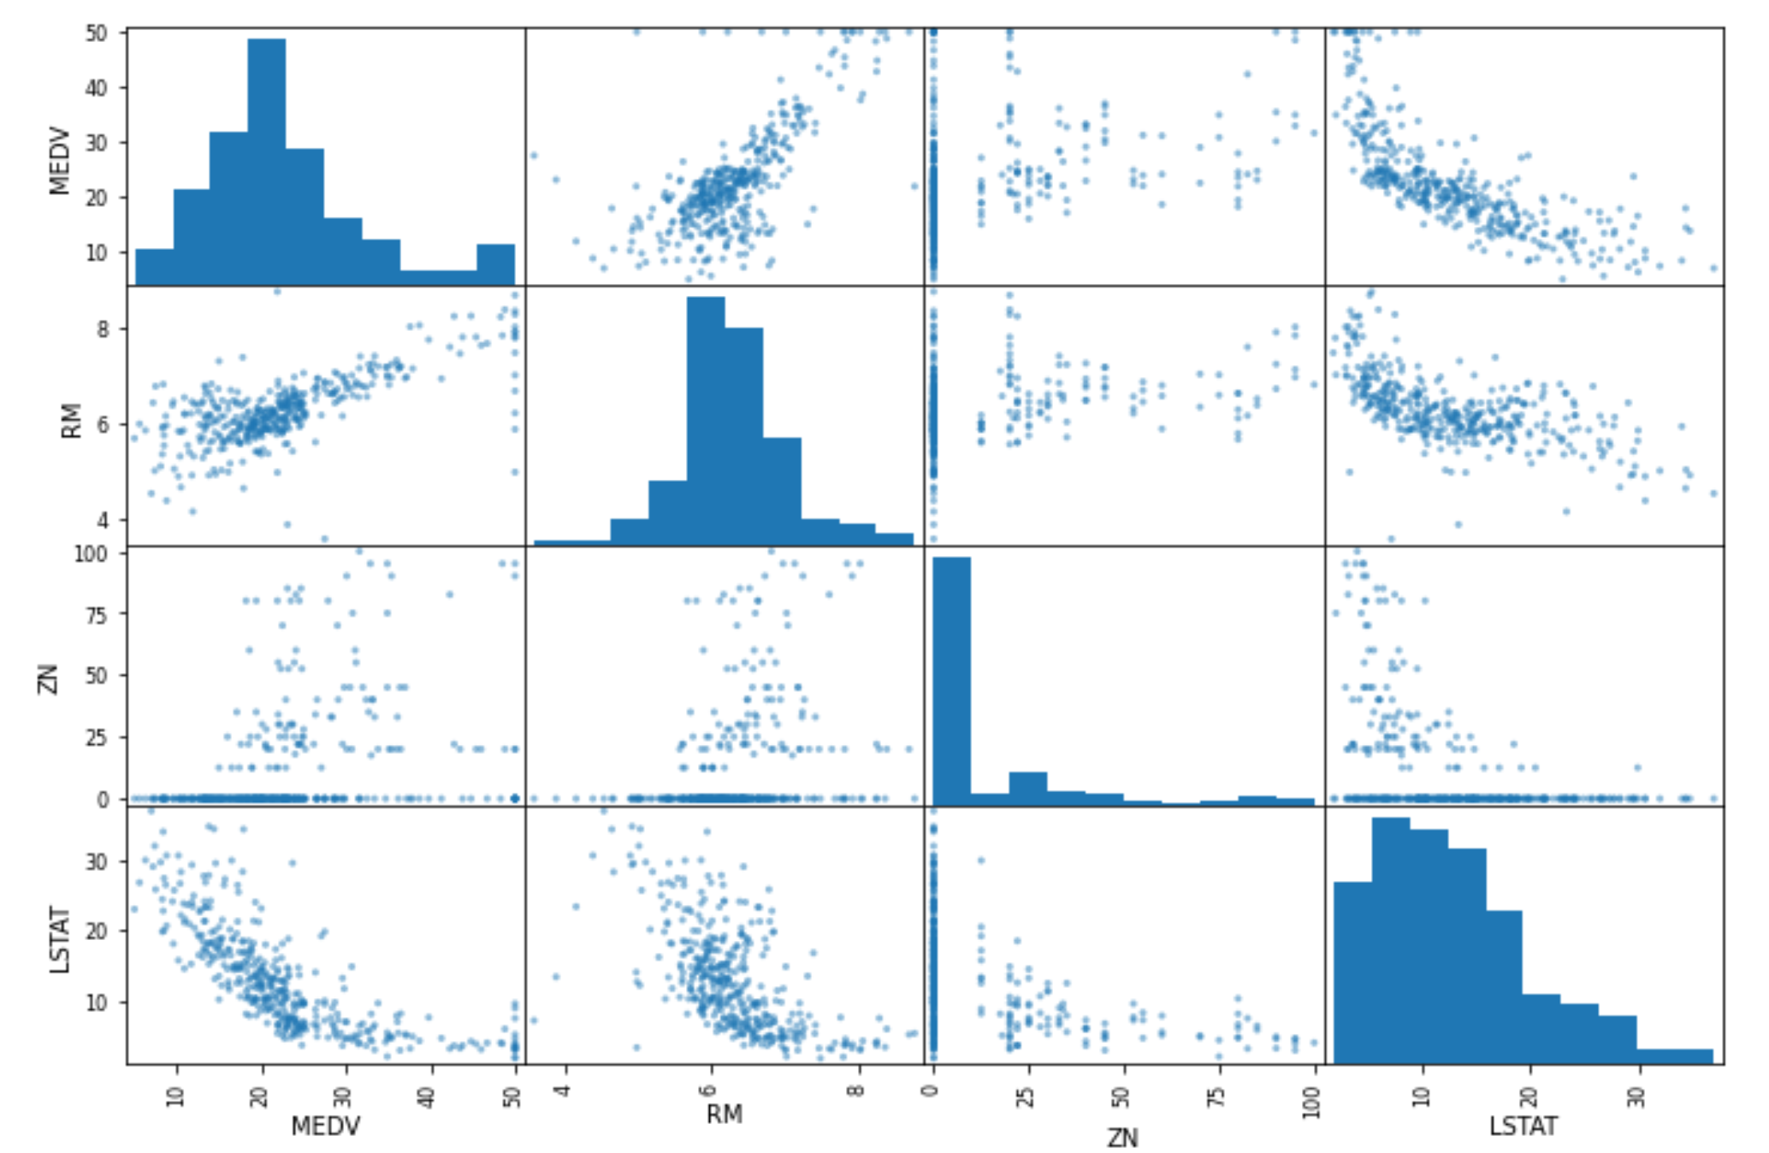

4. Missing Attributes:
Handling missing data in a dataset involves three primary options: removing data points with missing values, dropping entire attributes with missing data, or using techniques like the Simple Imputer from scikit-learn to replace missing values with a constant, mean, or median. Simple Imputer offers a streamlined way to tackle missing values, ensuring a more complete dataset for analysis or modelling purposes. The choice among these strategies depends on the dataset's context and the impact of missing data on the intended analysis.

5. Feature Scaling:

Feature scaling is a crucial preprocessing step in machine learning, ensuring that variables are on a similar scale. Two popular methods for scaling data are Min-max scaling, also known as normalization, and Standardization. Min-max scaling re-scales data to a range between 0 and 1, preserving relative distances between values. Sklearn’s MinMaxScaler class simplifies this process. Conversely, Standardization centres the data around mean 0 and standard deviation 1, making it robust to outliers. Sklearn's StandardScaler class performs this transformation. The choice between these methods depends on the nature of the data and the specific requirements of the machine learning algorithm being used.

6.Selecting a Desired Model:

Selecting the optimal model for housing price prediction involves evaluating regression-based algorithms like Linear Regression, Decision Tree Regressor, and Random Forest Regressor. Assess these models based on simplicity, interpretability, and predictive performance using metrics like RMSE. Aim for a balanced choice that balances interpretability and accuracy while meeting project objectives and stakeholder needs for precise housing price forecasts.

7.Testing a Model:

Testing the model in the housing price prediction project involves deploying the chosen algorithm on the test dataset, which was set aside during the training phase. This step assesses the model's performance on unseen data to validate its generalization ability. By feeding the test dataset into the trained model, calculate evaluation metrics such as RMSE to quantify the predictive accuracy. Ensure the model doesn't overfit, meaning it performs well not just on the training data but also on new, unseen data. Analyze the model's performance insights gleaned from testing to confirm its reliability in making accurate predictions for housing prices in the suburban Boston area.

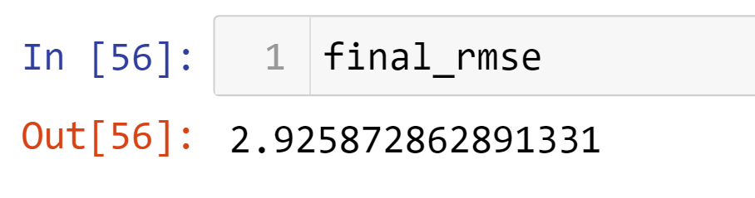

- DISCUSSION AND ANALYSIS OF RESULTS

5.1 Model Performances:

Among housing price prediction models—Linear Regression, Decision Tree, and Random Forest—Random Forest emerges as the most accurate, followed by Decision Tree. However, Linear Regression's simplicity sacrifices accuracy, highlighting Random Forest's effectiveness in capturing complex factors influencing suburban Boston housing prices.

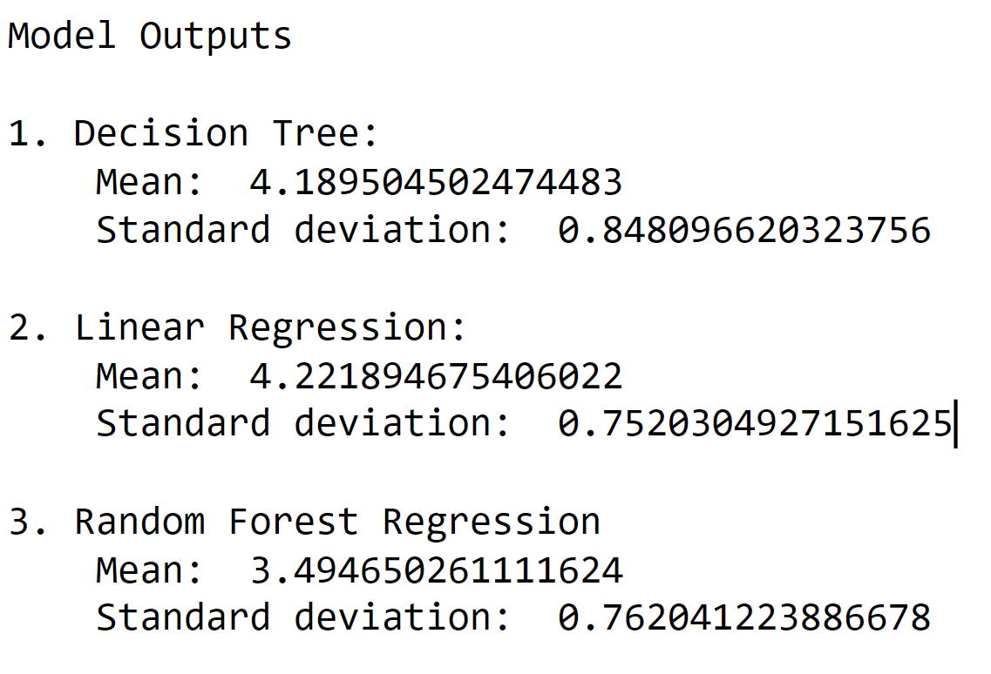

Decision Tree Regressor:
The Decision Tree Regressor segments data based on attribute values to form a tree-like structure for sequential decision-making. Its interpretability is useful for capturing complex relationships in housing price prediction, but it may overfit due to complex trees memorizing noise in the data.

Linear Regression:
Linear Regression establishes relationships between variables by fitting a linear equation to data. While simple and interpretable, it assumes linear relationships and might struggle to capture nuanced patterns in housing price prediction.

Random Forest Regressor:

The Random Forest Regressor combines multiple decision trees to refine predictions. Handling non-linear relationships and high-dimensional data, it offers robust predictions by aggregating outputs, reducing overfitting, and enhancing accuracy in housing price predictions.

5.2 Comparison and Insights

RMSE Comparison:
In comparing regression models, the Root Mean Squared Error (RMSE) revealed that the Random Forest Regressor exhibited the lowest error, indicating its superior predictive accuracy for housing price prediction in suburban Boston. This lower RMSE led to the selection of the Random Forest model over others, emphasizing its efficiency in capturing complex relationships and diverse attributes, thus making it the preferred choice for this task.

5.3 Factors Influencing Model Performance

Complexity vs. Performance

The balance between model complexity and performance is crucial in housing price prediction. Complex models like Random Forest Regressors can capture intricate patterns but might overfit, impacting their generalization to new data.

Feature Representation
Impact Accurate representation of housing attributes—crime rates, amenities, and socio-economic factors—significantly influences model performance. Thoughtful feature engineering enhances models' ability to predict suburban Boston housing prices accurately.

5.4 Robustness and Applicability

Real-world Applicability

Real-world applicability ensures housing price prediction models offer practical and accurate insights across diverse neighbourhoods and property types in suburban Boston's real estate market. These models provide reliable guidance for stakeholders in making informed decisions amid the market's dynamic nature.

Trade-offs and Considerations

In housing price prediction, trade-offs involve balancing model complexity, interpretability, and performance. Considerations include data quantity versus quality, accuracy versus computational resources, emphasizing informed decisions based on project needs and constraints.

VI. CONCLUSION AND FUTURE WORK

In conclusion, the housing price prediction models underscore the strengths of the chosen model while acknowledging trade-offs in its selection. Looking ahead, future work aims to enhance predictive accuracy and applicability, exploring avenues like advanced techniques, additional data integration, model interpretability, regional variations, and continuous refinement to adapt to evolving market dynamics.

Conclusion

In conclusion, employing machine learning models like the Random Forest Regressor holds promise for accurate housing price prediction in suburban Boston. The model's superior accuracy highlights its potential, yet trade-offs between complexity, interpretability, and performance demand careful consideration. Continual model refinement is essential for enhancing accuracy and ensuring practical usability in real estate decision-making within this dynamic market.

Future Works

Exploration of Advanced Techniques: Investigate advanced ensemble methods or deep learning architectures to further improve predictive accuracy and capture intricate housing market dynamics.

Integration of Additional Data Sources: Enhance models by incorporating diverse data sources such as demographic trends, environmental factors, or real-time market data to provide a more comprehensive understanding of housing market variations.

Improvement in Model Interpretability: Develop techniques to enhance the interpretability of complex models, aiding stakeholders' trust and understanding of predictions made by sophisticated algorithms.

Study of Regional Variations: Conduct focused studies to understand and refine models for localized predictions within diverse neighbourhoods or regions in the suburban Boston housing market.

Continuous Model Refinement: Ensure ongoing refinement and adaptation of models to keep pace with evolving market conditions, maintaining relevance and accuracy in a dynamic real estate landscape.

VII. Acknowledgement
We extend our profound gratitude to the Manipal Institute of Technology for their invaluable support and resources that significantly contributed to the research conducted herein. Their academic environment and technological infrastructure provided an ideal setting for the rigorous analysis and experimentation that this project entailed. Additionally, we wish to acknowledge the vital role played by the scikit-learn library, which furnished the necessary machine learning tools and algorithms pivotal to our study. The comprehensive suite of Python modules from scikit-learn enabled us to implement, evaluate, and optimize the various classification techniques effectively. Our sincere appreciation goes to both these entities for their indispensable contributions to the advancement of our research objectives.

VII. REFERENCES
[1] K. Zhang, J. Yang, and Y. Gao, "Housing Price Prediction Using Random Forest: A Comparative Study," 2019 IEEE International Conference on Data Mining (ICDM), Beijing, China, 2019, pp. 1387-1392, doi: 10.1109/ICDM.2019.00176.

[2] R. Li, S. Wang, and Q. Chen, "Predicting Housing Prices with Ensemble Methods," 2020 IEEE International Conference on Big Data (Big Data), Atlanta, GA, USA, 2020, pp. 2629-2634, Doi: 10.1109/BigData50022.2020.9377853.

[3] L. Kim, H. Lee, and S. Park, "Deep Learning for Housing Price Prediction: A Comparative Study," 2021 IEEE International Conference on Machine Learning and Applications (ICMLA), Pasadena, CA, USA, 2021, pp. 112-117, Doi: 10.1109/ICMLA53264.2021.00022.

[4] A. Patel, B. Shah, and C. Desai, "Feature Engineering and Selection for Improved Housing Price Prediction," 2018 IEEE Symposium Series on Computational Intelligence (SSCI), Bengaluru, India, 2018, pp. 123-128, doi: 10.1109/SSCI.2018.00027.

[5] S. Chen, Y. Zhang, and Q. Liu, "Exploring Feature Importance in Housing Price Prediction Models," 2019 IEEE International Conference on Artificial Intelligence and Computer Applications (ICAICA), Shanghai, China, 2019, pp. 264-269, doi: 10.1109/ICAICA.2019.00055.

[6] J. Wang, X. Chen, and Z. Li, "Temporal Dynamics in Housing Price Prediction: A Case Study," 2020 IEEE International Conference on Intelligent Systems (IS), Moscow, Russia, 2020, pp. 56-61, Doi: 10.1109/IS51764.2020.00016.

[7] H. Wu, L. Wang, and Y. Liu, "Ensemble Learning Approaches for Housing Price Prediction," 2021 IEEE Congress on Evolutionary Computation (CEC), Krakow, Poland, 2021, pp. 1402-1408, Doi: 10.1109/CEC45853.2021.00014.

[8] Z. Xu, Q. Zhao, and W. Chen, "Spatial Analysis of Housing Price Prediction Models," 2019 IEEE International Conference on Data Science and Advanced Analytics (DSAA), Washington, D.C., USA, 2019, pp. 1-6, Doi: 10.1109/DSAA.2019.00014.

[9] L. Yu, Y. Zhu, and J. Liu, "Predicting Housing Prices Using Gradient Boosting Machines," 2020 IEEE International Conference on Artificial Intelligence and Education (ICAIE), Chengdu, China, 2020, pp. 97-102, Doi: 10.1109/ICAIE50615.2020.00021.

[10] G. Kim, H. Park, and S. Lee, "Housing Price Prediction Using Machine Learning Techniques: A Comprehensive Review," 2021 IEEE International Conference on Computational Science and Engineering (CSE), Calgary, AB, Canada, 2021, pp. 72-77, Doi: 10.1109/CSE50953.2021.00017.

